**Prototype Design Pattern**

The Prototype design pattern is a creational pattern that allows cloning of existing objects without making the code dependent on their classes. This pattern is used when the cost of creating a new instance of a class is expensive or complex.

**Definition**

The Prototype pattern involves creating new objects by copying or cloning existing objects, which helps to avoid the overhead associated with the creation of objects using the new keyword.

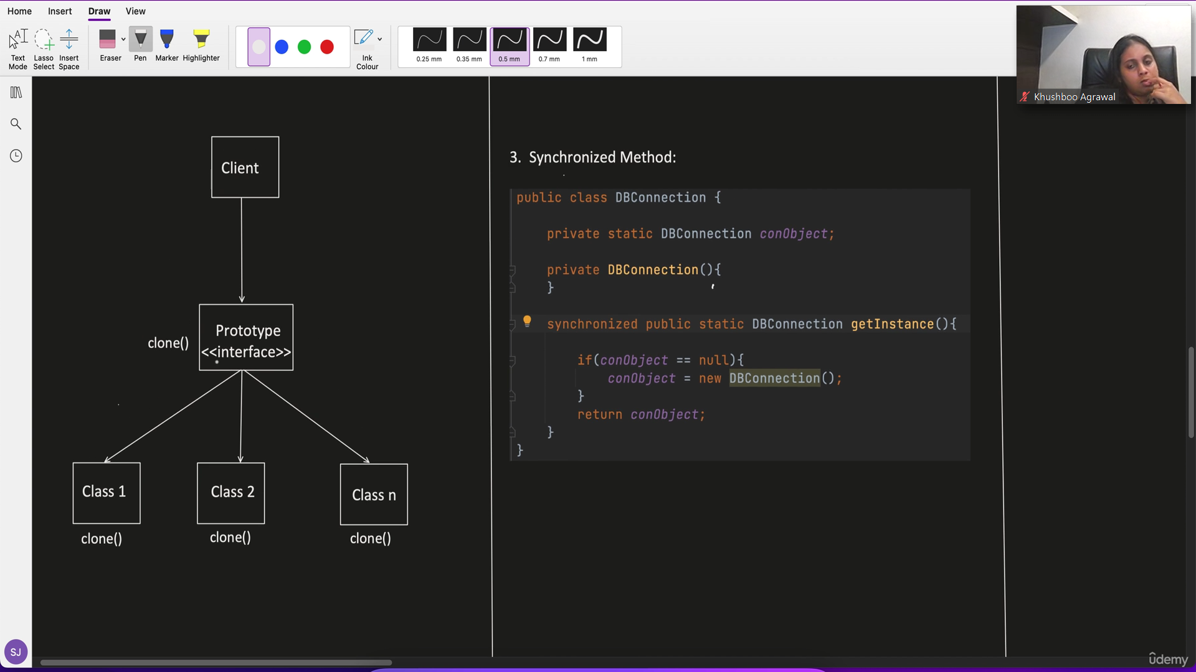

**Example**

Consider a scenario where we need to create multiple instances of complex objects.

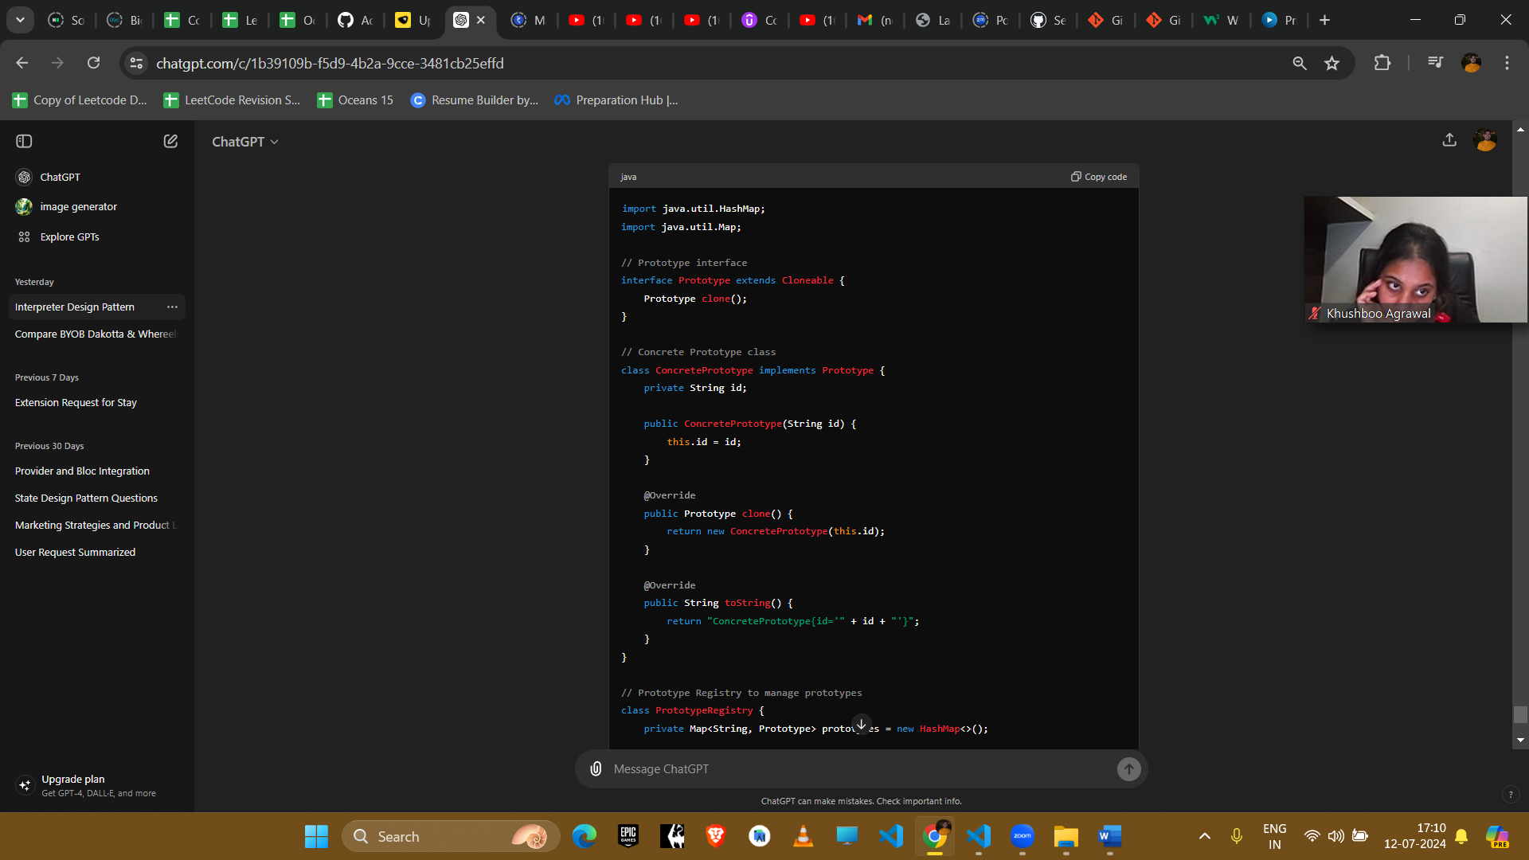

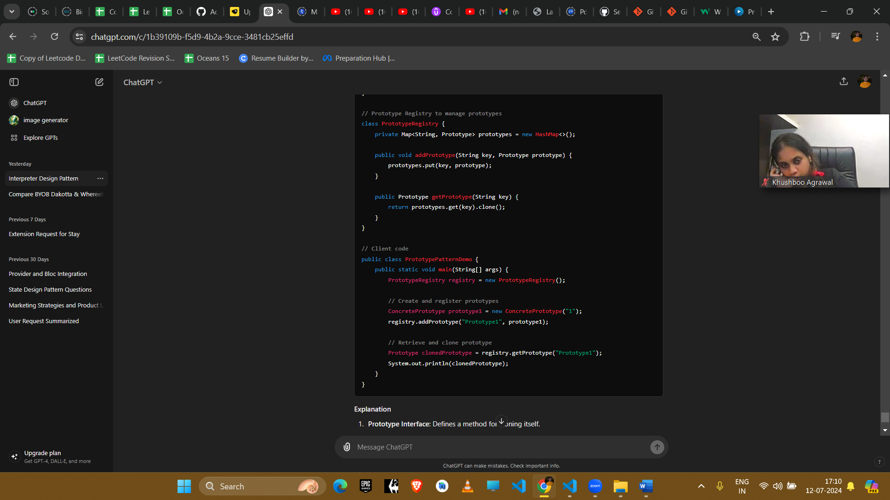

**Explanation**

1. **Prototype Interface**: Defines a method for cloning itself.
2. **Concrete Prototype Class**: Implements the clone method to create a copy of the object.
3. **Prototype Registry**: Manages the prototypes and provides a method to clone them.
4. **Client Code**: Uses the registry to create copies of the prototypes.

**Example Uses in Amazon Interviews**

1. **Document Templates**
   * **Scenario**: Creating multiple instances of document templates.
   * **Implementation**: Use the Prototype pattern to clone existing document templates, allowing quick creation of new documents based on a predefined structure.
2. **Game Development**
   * **Scenario**: Creating multiple instances of game characters or levels.
   * **Implementation**: Use the Prototype pattern to clone existing characters or levels, enabling quick and consistent creation of new instances with predefined attributes.
3. **Configuration Management**
   * **Scenario**: Managing configuration settings that need to be replicated across different environments.
   * **Implementation**: Use the Prototype pattern to clone configuration settings, ensuring consistency and reducing the complexity of creating new configurations from scratch.
4. **Prototyping and Testing**
   * **Scenario**: Creating multiple test instances for prototyping and testing.
   * **Implementation**: Use the Prototype pattern to clone test instances, allowing quick and efficient creation of multiple objects for testing purposes.

**Conclusion**

The Prototype pattern is useful for scenarios where creating new instances of a class is expensive or complex. It helps to optimize performance and resource usage by allowing the creation of new objects through cloning. This pattern is commonly used in scenarios requiring the replication of objects with complex initialization or high creation costs.